**Environment Setup**

**Create a IBM CloudAccount**

**TEAM ID = PNT2022TMID47022**

**Project Name = Nutrition Assistant Application**

**Sudhir account**

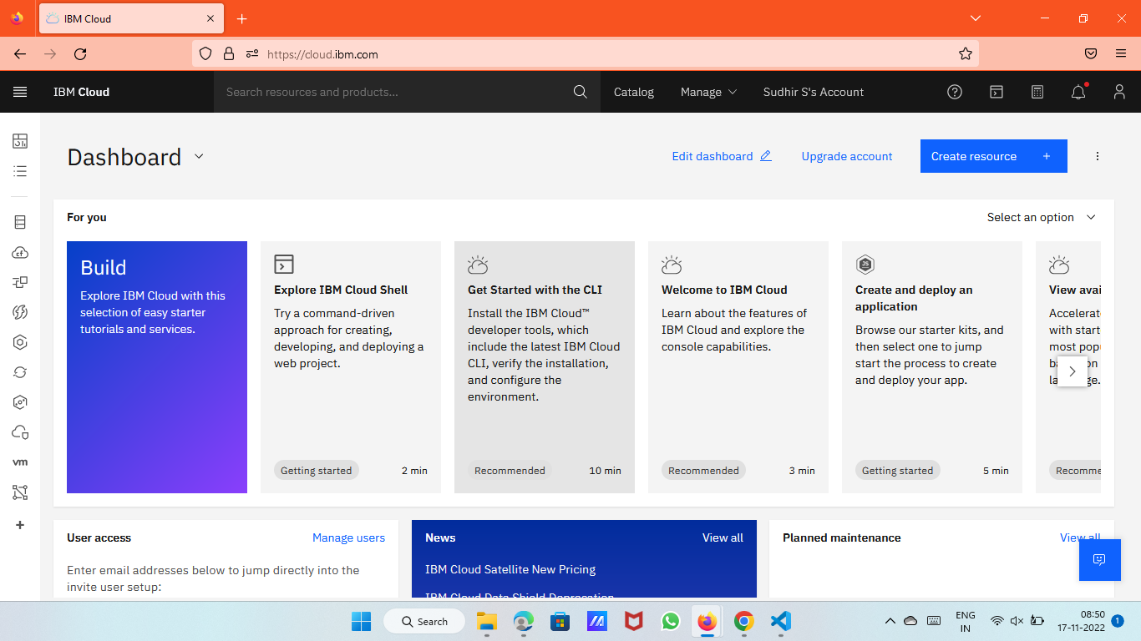

**Vincent account**

